Large quantity

📦 What Is "Large Quantity" (as a Quantifier)?
# Source: AI Source: Provided by: [Data Path: Persons Table -> ID Column: 1, Name_En Column: Motasem Essam] -> From: [ChatGPT] on [7/28/2025]
Large quantity quantifiers are determiners used to show that there is a lot of something.
They answer: "How many?" or "How much?"

✅ Common Large Quantity Quantifiers
# Source: AI Source: Provided by: [Data Path: Persons Table -> ID Column: 1, Name_En Column: Motasem Essam] -> From: [ChatGPT] on [7/28/2025]
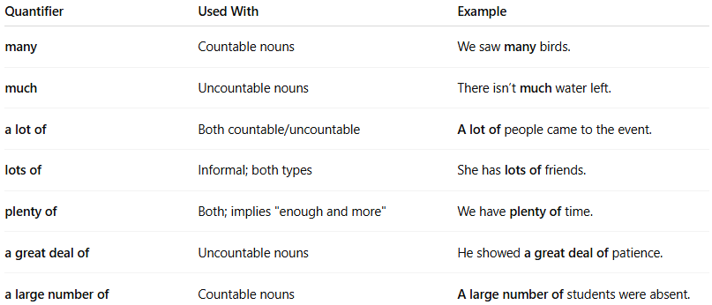
Quantifier | Used With | Example
many | Countable nouns | We saw many birds.
much | Uncountable nouns | There isn’t much water left.
a lot of | Both countable/uncountable | A lot of people came to the event.
lots of | Informal; both types | She has lots of friends.
plenty of | Both; implies "enough and more" | We have plenty of time.
a great deal of | Uncountable nouns | He showed a great deal of patience.
a large number of | Countable nouns | A large number of students were absent.

🧠 Tips for Use
# Source: AI Source: Provided by: [Data Path: Persons Table -> ID Column: 1, Name_En Column: Motasem Essam] -> From: [ChatGPT] on [7/28/2025]
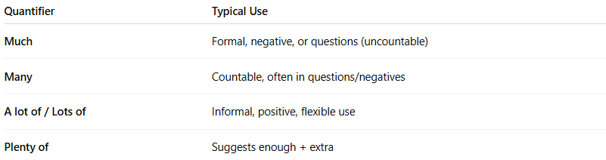
Quantifier | Typical Use
Much | Formal, negative, or questions (uncountable)
Many | Countable, often in questions/negatives
A lot of / Lots of | Informal, positive, flexible use
Plenty of | Suggests enough + extra

🔁 Examples:
# Source: AI Source: Provided by: [Data Path: Persons Table -> ID Column: 1, Name_En Column: Motasem Essam] -> From: [ChatGPT] on [7/28/2025]
- ✅ Much money was wasted.
- ✅ Many children love ice cream.
- ✅ She has a lot of experience.
- ✅ There is plenty of food for everyone.

